Data logging
EEZ BB3 provides simple data logging of up to 4 output values of installed power modules. Logged output values can be voltage, current or power. Logged data is stored on the SD card and can be viewed while the logging is in progress or upon completion or termination of logging.
Finally, it will be possible to transfer logged data to a computer using the EEZ Studio application or using similar applications using SCPI commands.

Data logging  To start data logging, tap on the Dlog icon, when a menu will open with the following options:  Log U – check for the output voltage on the selected channel.  Log I – check for the output current on the selected channel.  Log P – check for the output power on the selected channel.  By default, voltage and current on channel 1 is selected. | 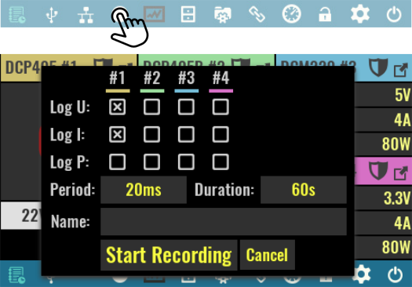
Period
Specifies the sampling rate of data logging, i.e. the time between two measurements to be recorded. For example, if the period is 20 ms, this means that measurements will be taken 50 times per second.

Duration
Max. duration of data logging. If you want continuous data logging, enter infinity (∞) from keypad. Logging can be interrupted at any time with a new tap on the Dlog icon when its color has changed to red. Once interrupted data logging cannot be resumed.

Name
The name of the file where the logged data will be stored. The file with the name entered will be created on the SD card in the Recordings folder. If the file name is not entered, the current time and date will be used in the following format: yyyy_mm_dd-hh_mm_ss.dlog.

The Start recording option triggers data logging when the color of the Dlog icon will change to red. The output values being recorded will also be clearly marked.  Data logging can be interrupted at any time, and cannot last longer than the Duration set. If duration infinity (∞) is selected, logging will continue while EEZ BB3 is active and will be limited by free space available on the SD card. | 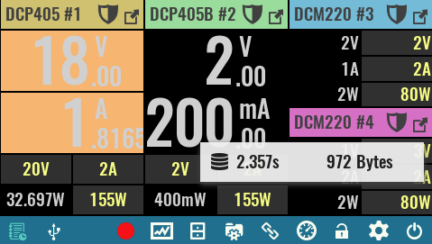
During data logging, a floating menu will appear that will be able to move anywhere on the screen, displaying the elapsed time and data size.

Displaying recorded data
Log viewer lets you view recorded data while data logging is in progress. In this case, the recorded data will be displayed at the rate at which it was sampled (i.e. if the period is set at half a second, then new data will also appear every half a second).  The status bar will show information about the elapsed time and data size, as well as a Dlog icon that can terminate logging early.  To return to the main page, use the Home icon. | 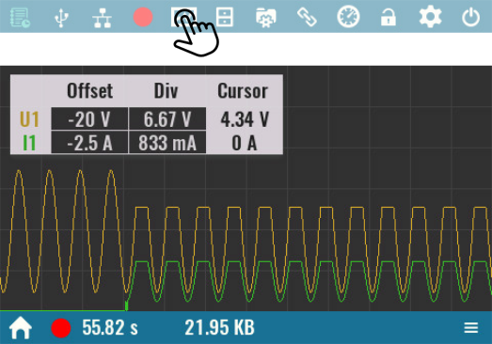
When logging is completed or terminated early, the log viewer will open automatically. It will now be possible to scroll through the recorded data using the following controls:  Time offset  Position on timeline from start of measurement. Moving along the timeline is possible by directly entering a new value with a numeric keypad, using an encoder knob, or using a scroll bar on the right side of the status bar. | 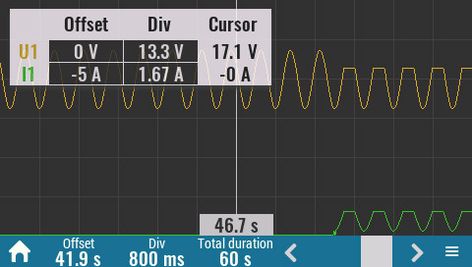
Time div
Logging data display area has 12 x 6 cells graticule that helps to determine time duration and measured amplitude more easily. This parameter defines the duration of one time division. The minimum duration is 800 ms and is determined by screen resolution and displaying principle (i.e. minimum one pixel per sample).

Total duration
Displays the total duration of logged data in seconds.

The log viewer will sort all recorded traces one above the other for better visibility. A floating (“unpined”) Legend menu will also appear in upper left corner that can be moved freely anywhere on the screen.
When opening the log viewer will sort all recorded traces one above the other for better visibility. However, this order can be changed as desired by changing the Offset parameter of each displayed trace. Trace y-axis offset can be changed in the following way:

❑ | Tap on the desired trace Offset cell on the Legend menu. | 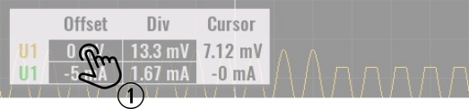
⬥ | Tap once again if you’d like to enter exact value of the new offset. The numeric keypad will appear and any value within displayed range can be entered (e.g. -100 to 100 V as shown below).  Offset value define trace position in reference to the middle of the viewing area that represents 0 V. | 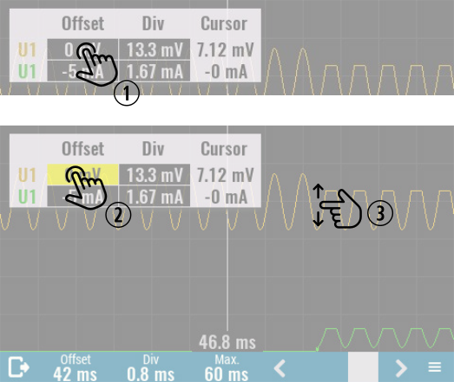
 |  | 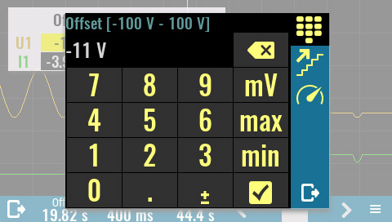
 | The trace offset can be also changed by simply tap on trace and move it new position. While moving displayed Offset value will change accordingly.

Trace amplitude can be changed in the similar way by changing its Div value in the Legend menu.

The Log viewer has in its right down corner an icon that provides access to the new menu with the following options:  Show legend  Displays or hide floating logged data legend.  Auto Scale  Reset Offset and Div values for the all traces to initial values.  Upload  Transfer logged data to the EEZ Studio. This option is available only if active connection exists (via USB or Ethernet). | 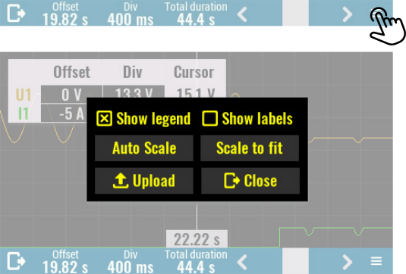

Show labels
Displays units on the right end of the trace.

Scale to fit
Maximize the view of all data traces.

Close
Close this menu.

Logged data transfer to a computer
❑ | Download the latest EEZ Studio available at https://github.com/eez-open/studio/releases and install it on your computer.
⬥ | Start EEZ Studio and double click on EEZ BB3 from the list of preinstalled instruments on the Home page.  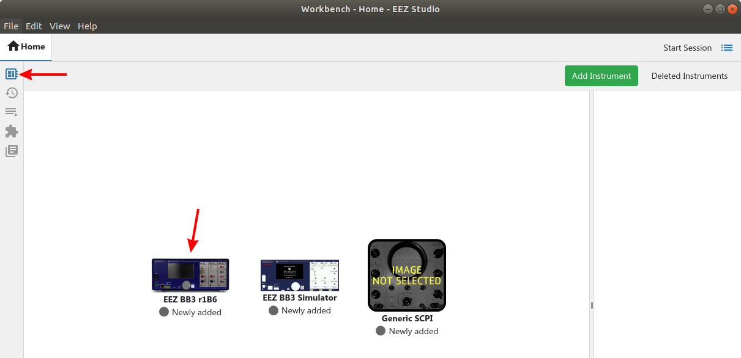
 | Select Connect option to open connection menu.  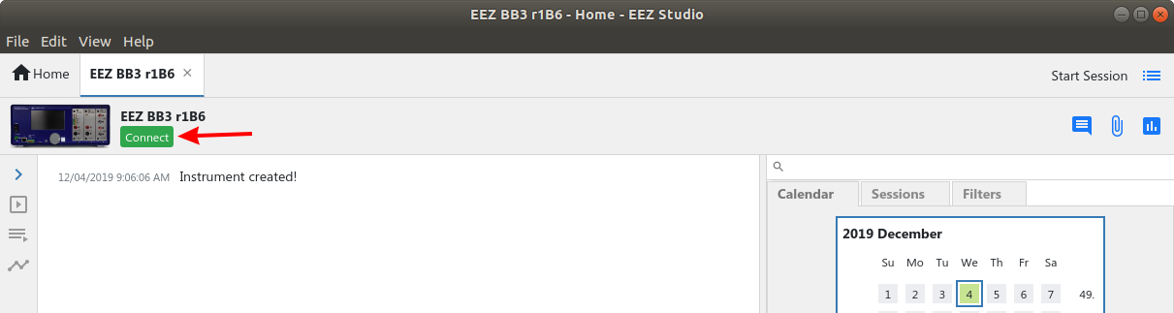
❒ | Select connection type, for USB choose Serial from Interface combo box. Click on Refresh button if EEZ - 2018 is not visible in the list of serial terminals.  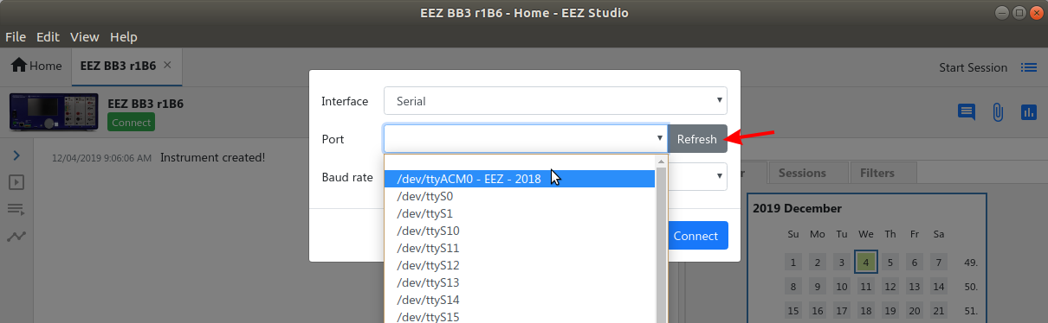  When Ethernet is selected as communication interface, the Server address has to be defined. Enter here EEZ BB3’s IP address (See Ethernet settings).  Successfully established connection is indicated by receiving identification string as response to *IDN? SCPI query that EEZ Studio will send automatically to the EEZ BB3 over the selected interface.  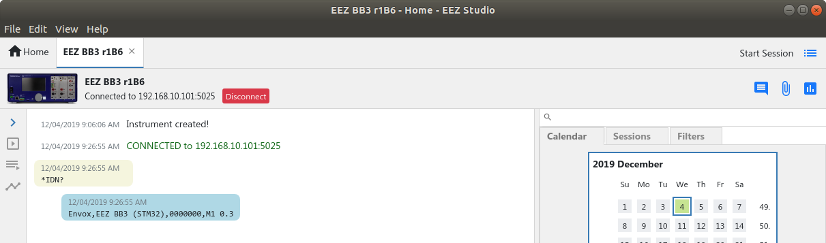

⧫ | Data log files are stored into Recordings folder on the SD card. To access that folder enter  MMEM:CDIR “Recordings”. The MMEM:CAT? query returns all data log filenames.  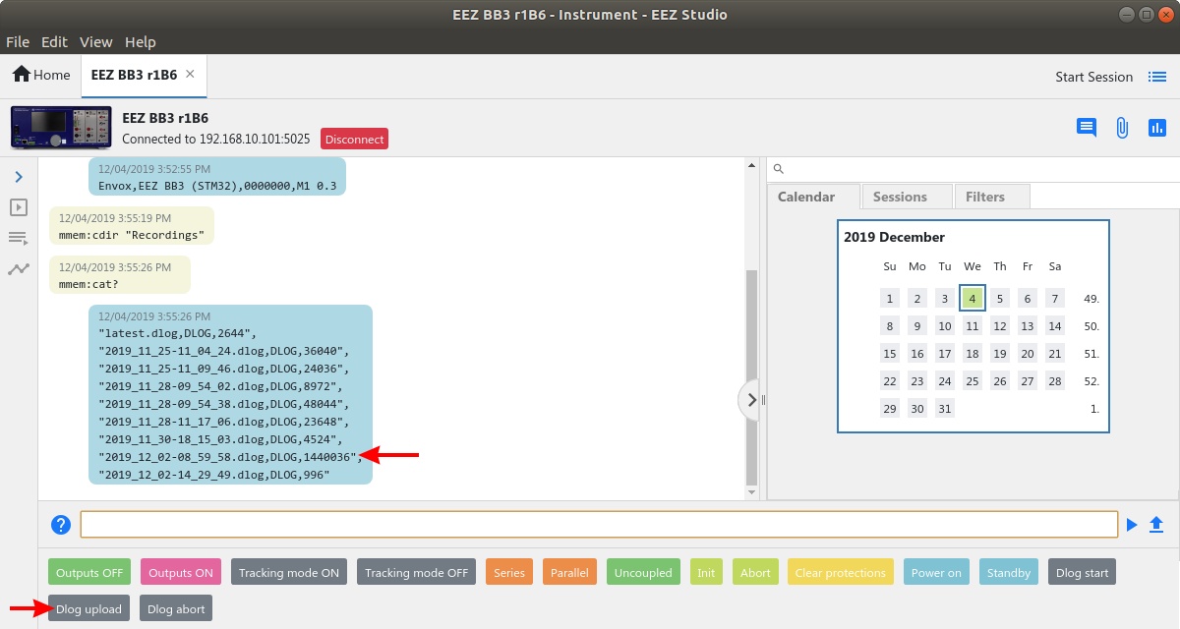  Select Dlog upload javascript from the list of the shortcuts.
 | Enter the data log file name:  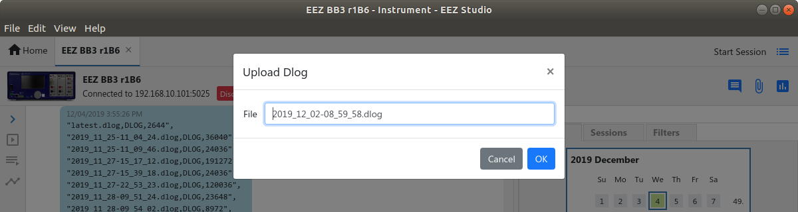
◆ | An upload progress bar will be displayed.  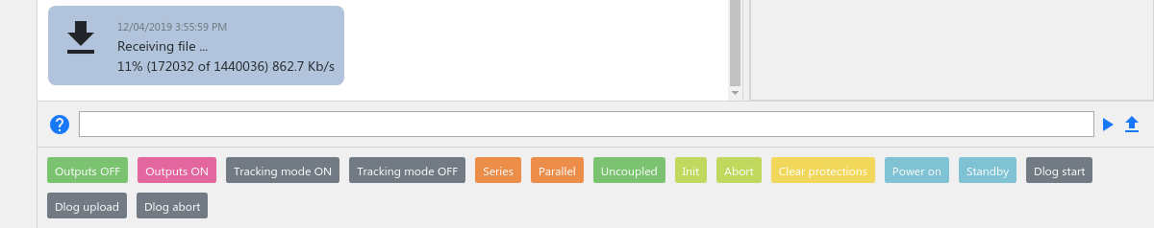
 | Data log will appear as new item in the SCPI session view. You can open it for further analysis with double click.  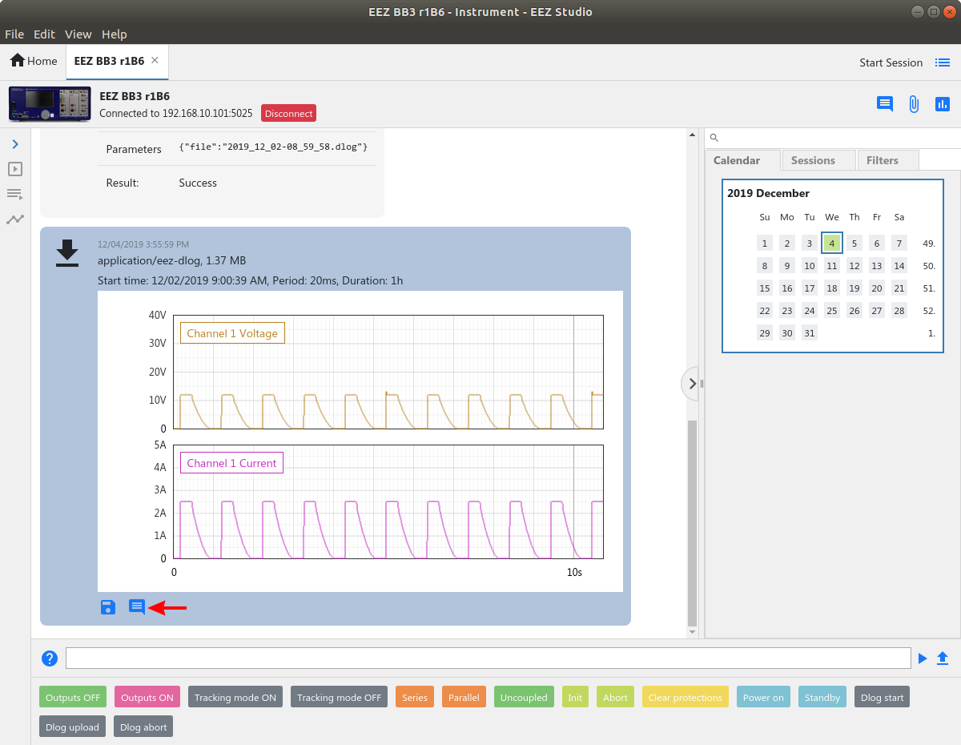

An arbitrary comment can be added by selecting the Comment icon when new entry form will appear:

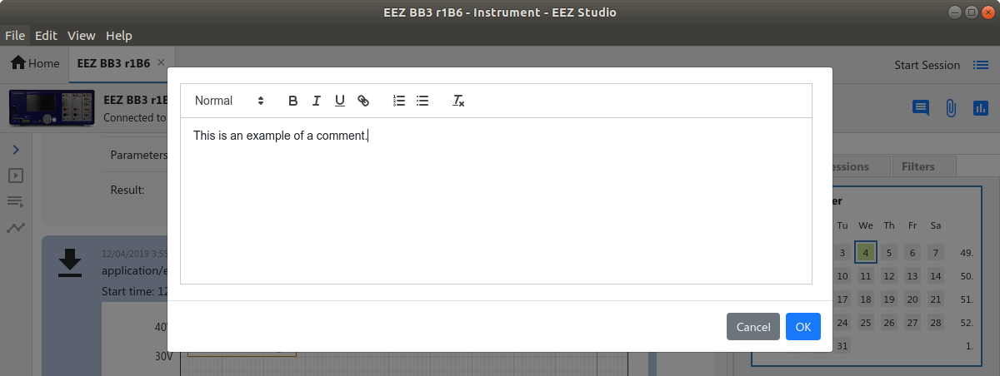

Once added, comment can be modified or deleted by hover mouse on comment area when two new icons will appear:

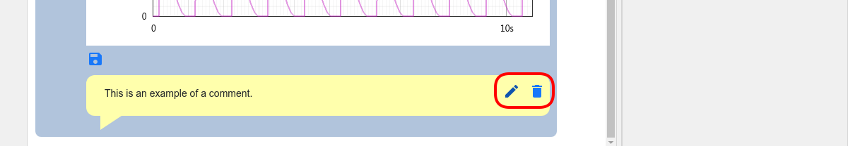

Initiate data log transfer on the EEZ BB3
Transferring the data log to the EEZ Studio can be initiated on the EEZ BB3, too. Before initiating the transfer, make sure that the connection with the EEZ Studio is established as described in steps  to  in previous section.

❑ | Open the File Manager and move to Recordings folder. | 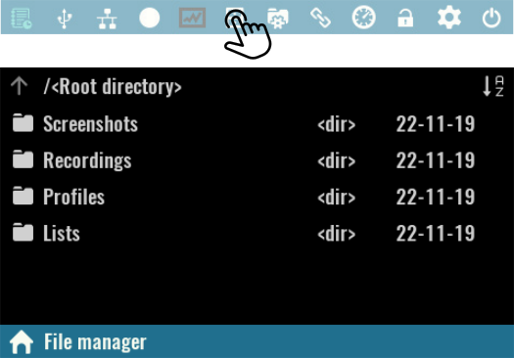

⬥ | Click on desired data log file and select Upload option from the menu. | 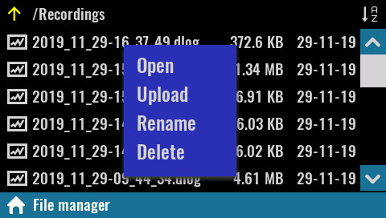

 | Wait until the data transfer is complete. | 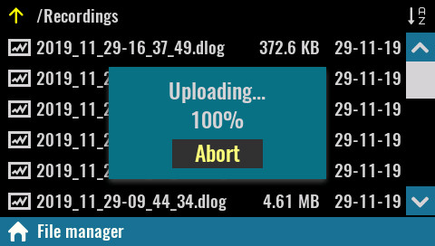

Establishing serial (via USB) communication with a Linux computer
EEZ Studio users on a Linux computer may receive a series of error messages every time they successfully connect to EEZ BB3 via the serial interface. The reason for this is the existence of a Modem manager application that will send a series of modem commands to the connected device (EEZ BB3 in this case). The EEZ BB3 has ability to interpret only SCPI commands and therefore on each modem command it will response with an error message.

If the Modem Manager application is not needed (i.e. there is not other serial devices connected on the computer) it can be simply deinstalled with the following command from the Terminal application:

sudo apt-get remove modemmanager

However, if you want to keep the Modem Manager, it can be configured to avoid sending unnecessary modem commands to the connected EEZ BB3 in the following way:

❑ | Start Terminal application and enter the following command to determine which filter policy Modem Manager is using on your system by viewing its status:  sudo systemctl status ModemManager  ● ModemManager.service - Modem Manager  Loaded: loaded (/lib/systemd/system/ModemManager.service...  Active: active (running) since ...  ...  CGroup: /system.slice/ModemManager.service  └─644 /usr/sbin/ModemManager --filter-policy=strict
⬥ | Modem Manager filter policy has to be changed from strict to default. Use your favorite text editor like gedit to make that modification:  sudo gedit /lib/systemd/system/ModemManager.service  Additionally you can add under [Service] section the following line:  Environment="MM_FILTER_RULE_TTY_ACM_INTERFACE=0"
 | After changing the service file, reload the systemctl configuration and restart Modem Manager:  sudo systemctl daemon-reload  sudo systemctl restart ModemManager  Optionally you can check once again the Modem Manager filter policy that should be like this:  ● ModemManager.service - Modem Manager  Loaded: loaded (/lib/systemd/system/ModemManager.service...  Active: active (running) since ...  ...  CGroup: /system.slice/ModemManager.service  └─1010 /usr/sbin/ModemManager --filter-policy=default

